**Quarterly Report – Public Page**

**Date of Report:** 2nd Quarterly Report - June 1, 2023

**Contract Number:** *693JK32210015POTA*

**Prepared for:** *DOT-PHMSA*

**Project Title:** *Dynamic Geohazard Risk and Decision Support Platform*

**Prepared by:**  *Boston Geospatial, Inc.*

**Contact Information:**  *Justin Oliveira,* [*justin@bostongeospatial.com*](mailto:justin@bostongeospatial.com)*, 781-975-3748*

**For quarterly period ending:** *March 31, 2023*

**1: Items Completed During this Quarterly Period:**

A detailed overview of the progress this past quarter is provided below. Unrelated to any invoiceable item, we made progress on the development of our TAP. We have added a professor of civil and structural engineering from Florida Tech to the TAP - notable he also has experience in seismic design. We plan to finalize our geotechnical academic TAP member in the coming weeks. And we will be attending the Common Ground Alliance (CGA) conference in Orlando in April as well as the American Gas Association (AGA) conference in Dallas in May to engage with potential TAP operators.

| ***Item #*** | ***Task #*** | ***Activity/Deliverable*** | ***Title*** |
| --- | --- | --- | --- |
| 3 | 1.2 | Acceptable Limits Module | Consolidate list of forcing functions (e.g. operating pressure, bending moment, fault displacement, etc.); Connect equation determinants to GIS/APDM fields; Implement python parametric model library for limit equations |
| 4 | 1.3 | Acceptable Limits Module | Submit Design Code Acceptable Limits Documentation |
| 5 | 0.1 | 2nd Quarterly Status Report | Submit 2nd quarterly report |

**2: Items Not-Completed During this Quarterly Period:**

N/A

**3: Project Financial Tracking During this Quarterly Period:**

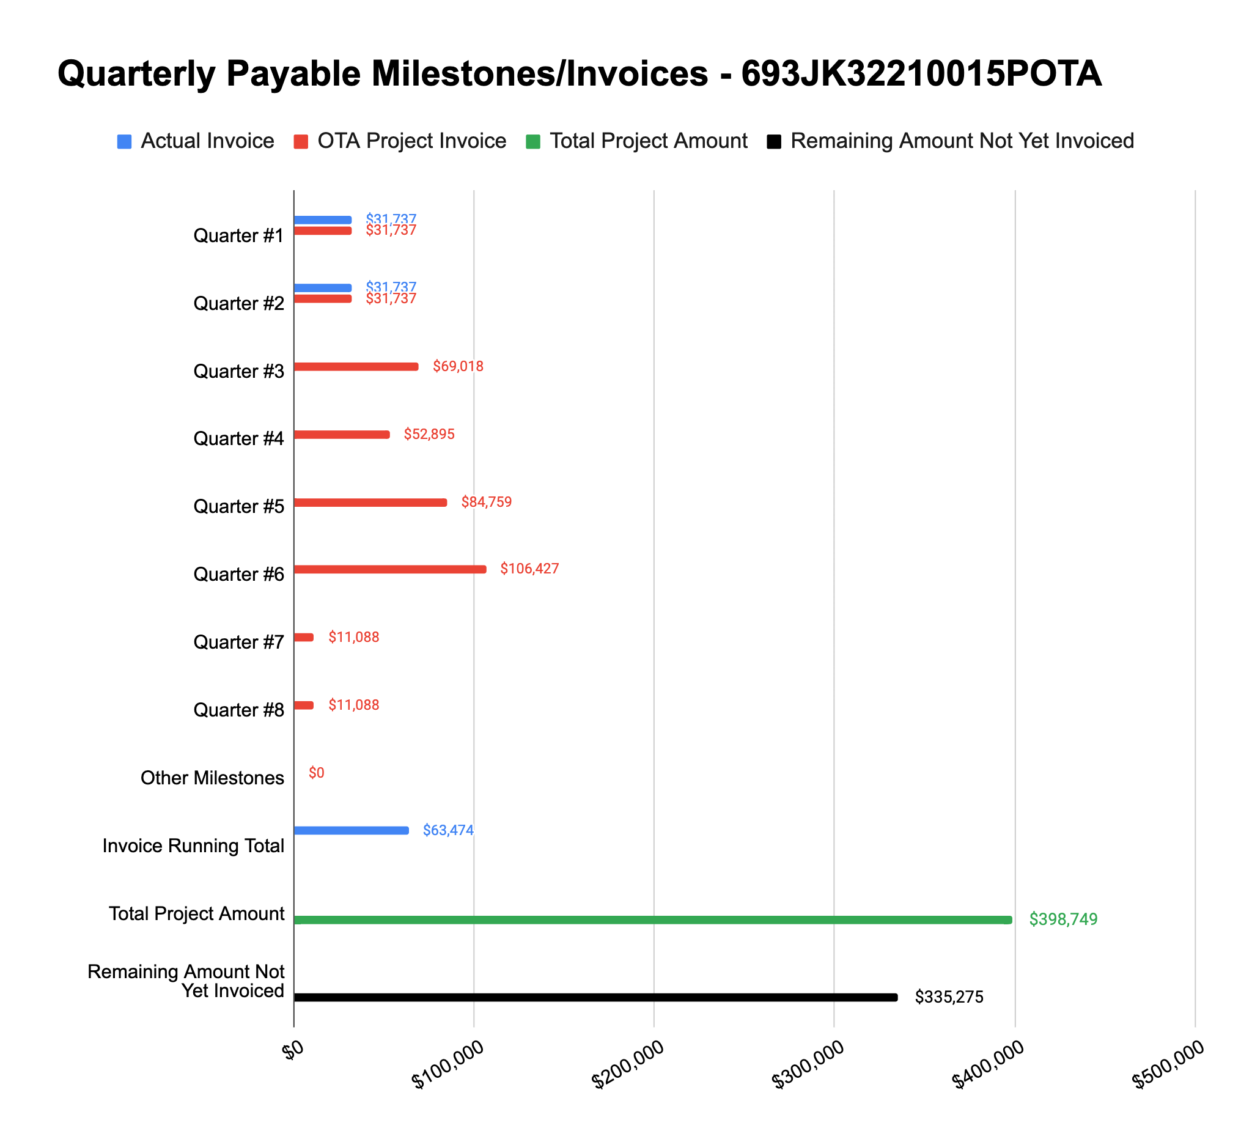

**4: Project Technical Status –**

**Item# 3 / Task# 1.2/ Acceptable Limits Module / Consolidate list of forcing functions (e.g. operating pressure, bending moment, fault displacement, etc.); Connect equation determinants to GIS/APDM fields; Implement python parametric model library for limit equations**

With the geohazard load cases designed, and the associated force/moment equations identified, the list of all determinants (including the forcing functions) was consolidated. And generally speaking, these all tie into APDM fields, fields that will be available by the geohazard datasets, or those that can be derived on-the-fly from either. An initial V&V has been performed on the load case libraries which have been implemented using python. These load cases are then combined together to get to an integrated component stress, the component stresses combined to get to a total stress (in accordance with ASME), ring buckling checks are performed, and then stress margins computed - the entire library code implementation and V&V is complete.

Several different geohazard load cases (karst, earth movement, landslide, seismic, and faulting) are included in the baseline version of the module at the moment - it also includes internal operating pressure, thermal loading, live loads (e.g. road crossings), and dead loads (static soil pressure). These non-geohazard load cases were added because they tend to be materiel sources of hoop (internal pressure as well as live and dead loading) and longitudinal (thermal) stress, and we are ultimately interested in an accurate tally of total stress along the pipe system (from geohazard and non-geohazard sources). Several of the load case equations come directly from the ASCE Guideline for the Design of Buried Steel Pipe, whereas simpler load cases come from classical engineering texts.

Each load case discussed above has an associated algorithm which takes in the dependent variables for each pipe segment from the GIS UPDM model (based on the 2021 Esri Utility and Pipeline Data Model framework) of the piping system, looks up boundary conditions from the various soil and geohazard geodatabases, and then computes the resultant load. Dependent variables are modeled in python as class objects - this allows us to track unique names of each variable, descriptions, and most importantly track the unit usage (and make conversions on the fly if needed). The load case equations were implemented as functions which can be vectorized or parallelized over large datasets quite easily. Furthermore, a V&V effort for each individual load case has been performed to ensure the implementation correctly follows the designed algorithm and check for accuracy - this was accomplished by having someone independently develop a set of hand calculations scenarios.

Given each pipe segment could have several load cases, the resultant forces, moments, or strains must be converted into a stress so they can be added together at the component level. This must be done to accurately estimate the principal stresses prior to computing a total stress. Once the combined stress is found, a comparison to the allowable stress can be made and margin estimated. All algorithms for the module are complete and an initial V&V has been performed.

Overall the V&V effort was originally meant to occur at a later stage in the project, however the team thought it would be more prudent to do some of it now in case issues arose with the algorithm designs, load equations, or other elements of the implementation process - if issues did arise, they would be more costly to address later on.

**Item# 4 / Task# 1.3/ Acceptable Limits Module / Submit Design Code Acceptable Limits Documentation**

The Design Code Acceptable Limits Documentation is complete and contains all the algorithm design and background information for each load case, combined stress calculations, buckling checks, and margin assessments - all tracked against the CFR and ASME flow down.

**Item# 5 / Task# 0.1/ 2nd Quarterly Status Report / Submit 2nd quarterly report**

Additional detail not necessary - this report constitutes the deliverable for Item# 5 / Task# 0.1

**5: Project Schedule –**

Overall our project is on schedule - we are now all caught up with the completion of Task# 1.2 and 1.3